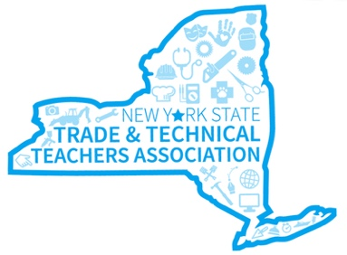
NY State Trade & Technical
Teachers Association

Statewide Cosmetology Teachers Collaboration Event
June 16, 2023 - OHM BOCES - New Hartford, NY

AGENDA
Registration
9:00 – 9:30 AM

Welcome / Overview
9:30 – 9:45 AM
Brenda Moore – NYSTTTA President

NYSED Updates
9:45 – 10:15 AM
Nicole Hadsell - Updates from SED and the DOS affecting Appearance Enhancement programs

CTE Technical Assistance Center Updates
10:15 – 10:45 AM

Mindy Iannotti – Updates to the CTE TAC resources and support that are available to everyone such as Asynchronous Professional Development and PLC resources

NYSTTTA Updates
10:45 – 11:15 AM
Dave Arntsen – Review NYSTTTA website updates, WBL support, and membership

Presentations by Burmax and Milady – Updates and Information on products and resources
11:15 – 12:15 PM

Lunch sponsored by
anddd
12:15 – 1:00 PM

Statewide Collaboration – Sharing Best Practice
1:00 – 2:30 PM
Teachers are asked to share one of their best learning activities and resources if available

Report Out
2:30 – 3:00 PM
Each group shares ideas from their table discussions

NYSTTTA Members - Annual Meeting and Election of Officers 3:00 – 3:30 PM

